**Schedule Updates**

This button opens a sub-menu of its own:

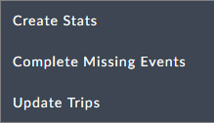

Create Stats

If you change costing parameters, you can change the KPIs accordingly without running the optimizer.

Complete Missing Events

This item opens up a choice dialog:

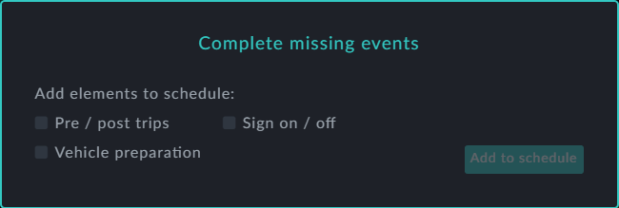

Check the elements required. If missing, they are auto-generated and added to the open schedule without touching the schedule.

Update Trips

This item opens a standard Windows Open File dialog. It applies the update to the open schedule.